https://chatgpt.com/g/g-p-6a5378cdfc588191b929a3b5ca9c1c9a/c/6a6aea6e-6794-83e8-a9d3-22852803845a

Step 2 — Confirm Trouble Ticket data exists
Run:
SELECT COUNT(*) AS total_trouble_tickets
FROM public.trouble_tickets;

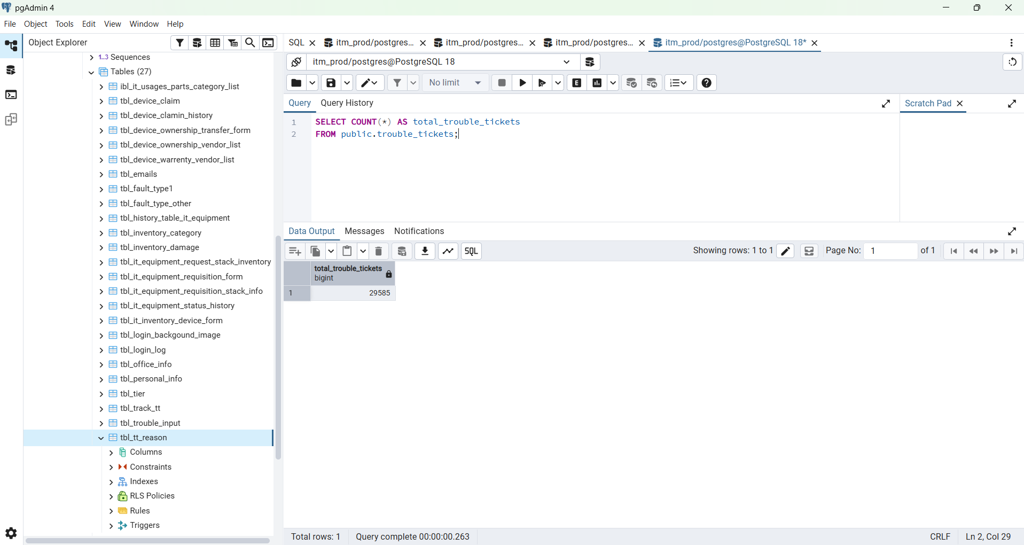

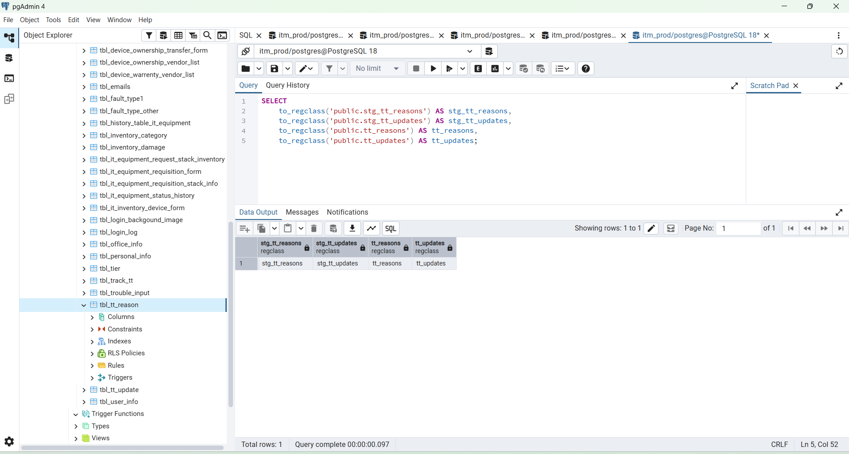

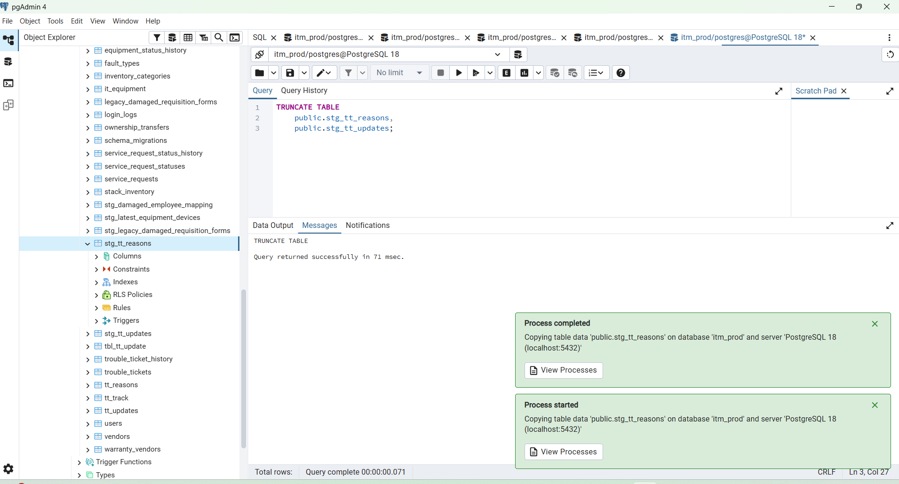

SELECT COUNT(*) AS reason_rows
FROM public.stg_tt_reasons;

Expected:
430

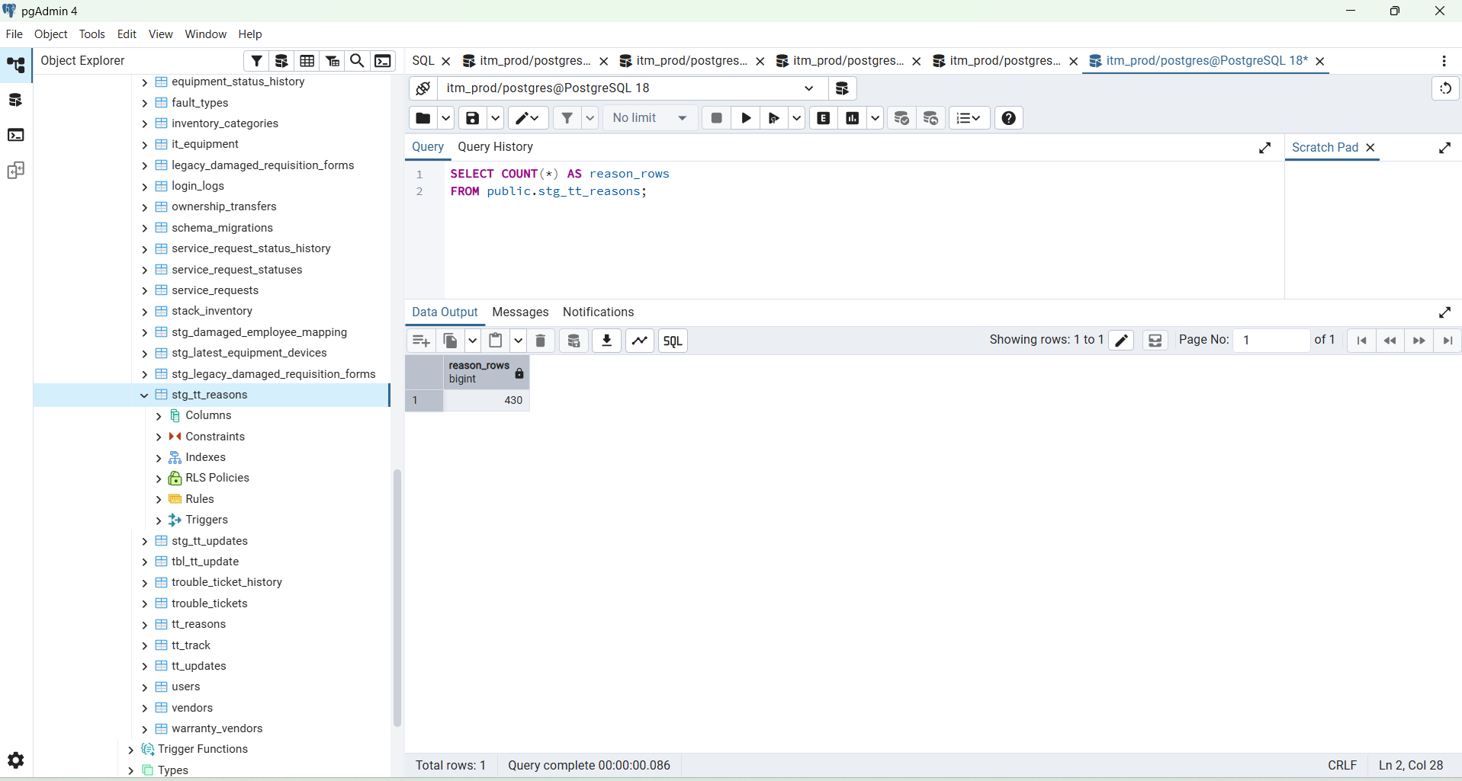

SELECT
id,
tt_no,
approved_val,
delivered_val
FROM public.stg_tt_reasons
WHERE BTRIM(tt_no) = '2026072129719';

Expected:
approved_val = 1
delivered_val = 0

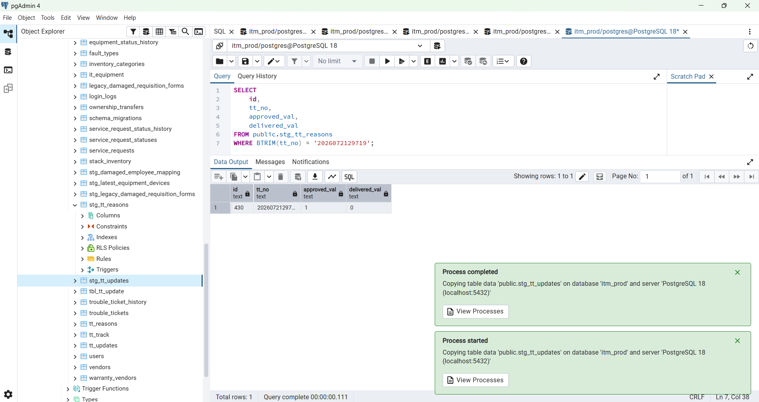

SELECT COUNT(*) AS update_rows
FROM public.stg_tt_updates;

Expected:
18010

SELECT
id,
tt_no,
client_name,
fault_update_date_time,
tt_note
FROM public.stg_tt_updates
ORDER BY id::bigint DESC
LIMIT 10;

SELECT
id,
tt_no,
client_name,
fault_update_date_time,
tt_note
FROM public.stg_tt_updates
ORDER BY id::bigint DESC
LIMIT 10;

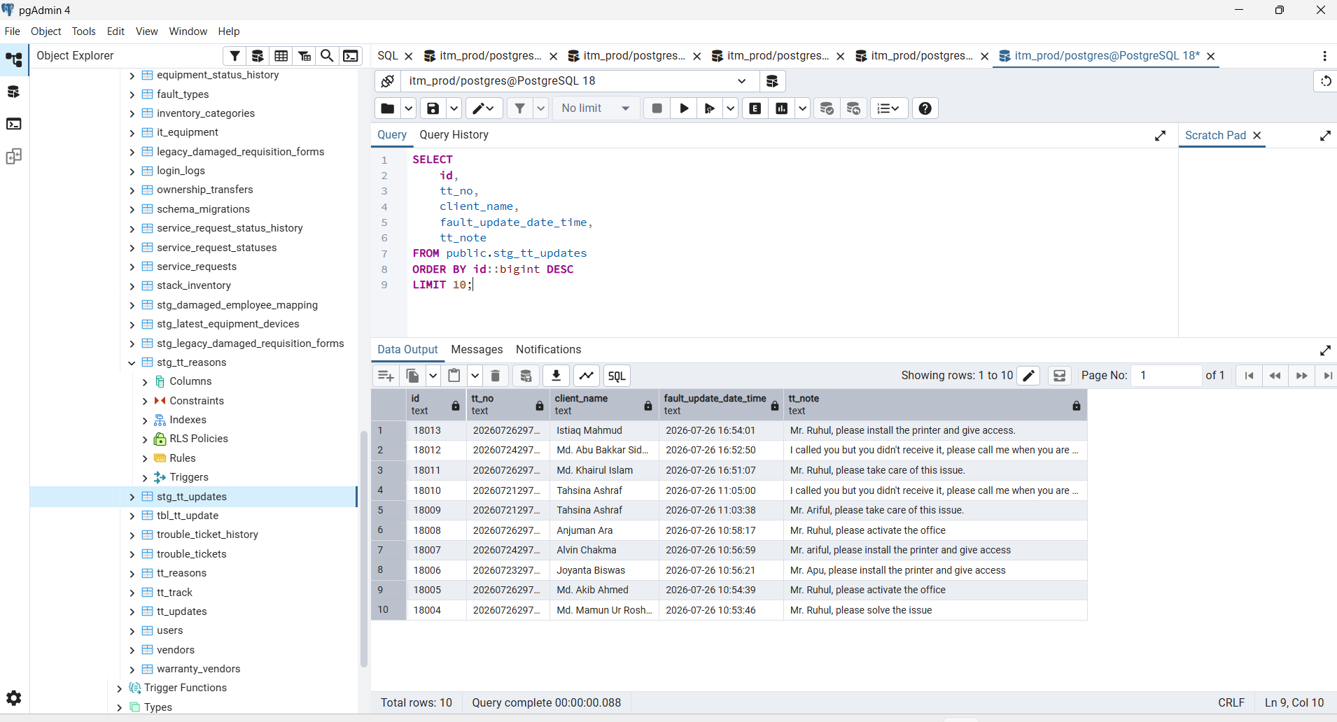

SELECT COUNT(*) AS decimal_tt_numbers
FROM public.stg_tt_updates
WHERE tt_no LIKE '%.0';

Expected:
0

Step 7 — Confirm both imports

SELECT
(
SELECT COUNT(*)
FROM public.stg_tt_reasons
) AS reason_rows,

(
SELECT COUNT(*)
FROM public.stg_tt_updates
) AS update_rows;

Expected:
reason_rows = 430
update_rows = 18010

Step 7 — Confirm both imports
Run:
SELECT
(
SELECT COUNT(*)
FROM public.stg_tt_reasons
) AS reason_rows,

(
SELECT COUNT(*)
FROM public.stg_tt_updates
) AS update_rows;
Expected:
reason_rows = 430
update_rows = 18010

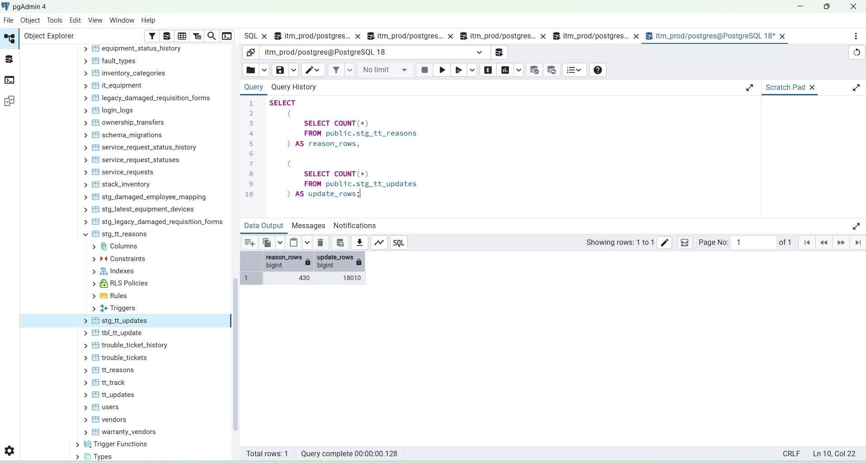

SELECT
(
SELECT COUNT(*)
FROM public.backup_tt_reasons_before_migration_20260809
) AS backup_reason_rows,

(
SELECT COUNT(*)
FROM public.backup_tt_updates_before_migration_20260809
) AS backup_update_rows;

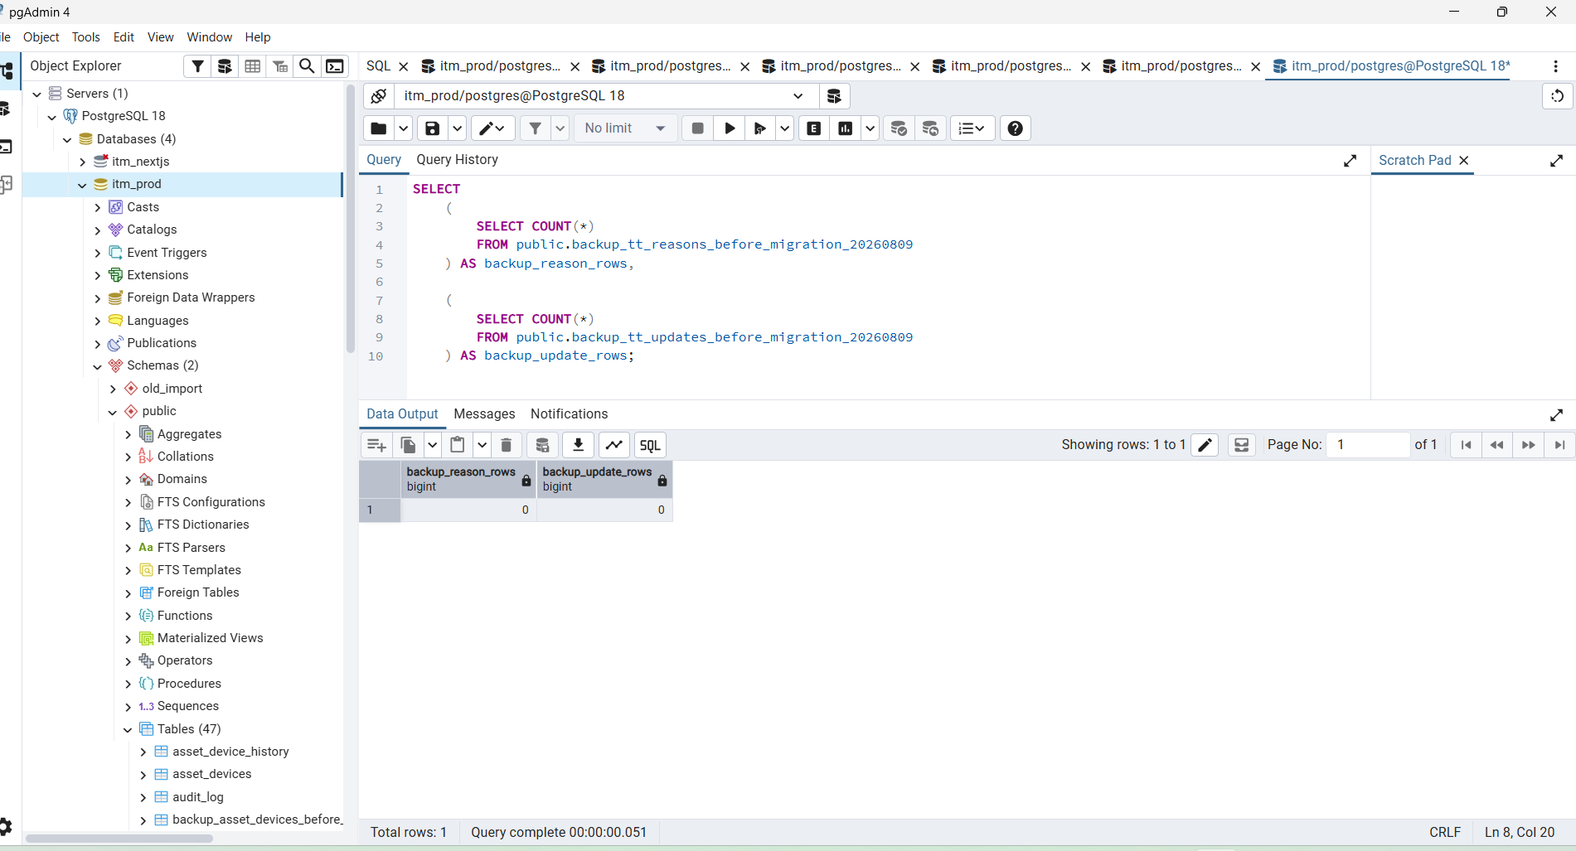

SELECT
(
SELECT COUNT(*)
FROM public.tt_reasons AS final
INNER JOIN public.stg_tt_reasons AS staging
ON final.id = NULLIF(BTRIM(staging.id), '')::bigint
) AS migrated_reason_rows,

(
SELECT COUNT(*)
FROM public.tt_updates AS final
INNER JOIN public.stg_tt_updates AS staging
ON final.id = NULLIF(BTRIM(staging.id), '')::bigint
) AS migrated_update_rows;

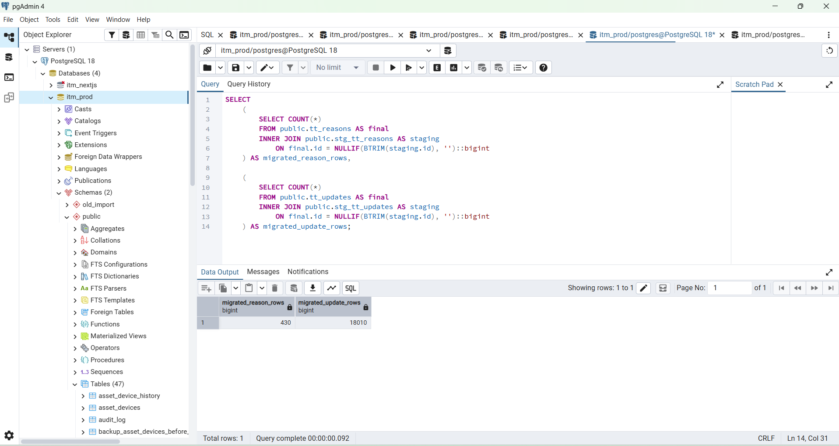

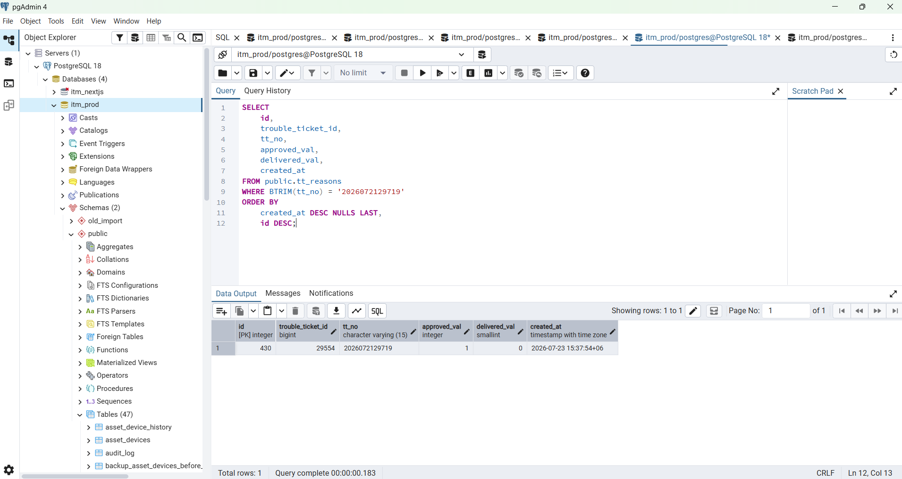

SELECT
id,
trouble_ticket_id,
tt_no,
approved_val,
delivered_val,
created_at
FROM public.tt_reasons
WHERE BTRIM(tt_no) = '2026072129719'
ORDER BY
created_at DESC NULLS LAST,
id DESC;

Expected:
approved_val = 1
delivered_val = 0

SELECT
indexname,
tablename
FROM pg_indexes
WHERE schemaname = 'public'
AND indexname IN (
'idx_tt_reasons_tt_no',
'idx_tt_reasons_trouble_ticket_id',
'idx_tt_updates_tt_no',
'idx_tt_updates_trouble_ticket_id',
'idx_tt_updates_fault_update_date_time'
)
ORDER BY indexname;

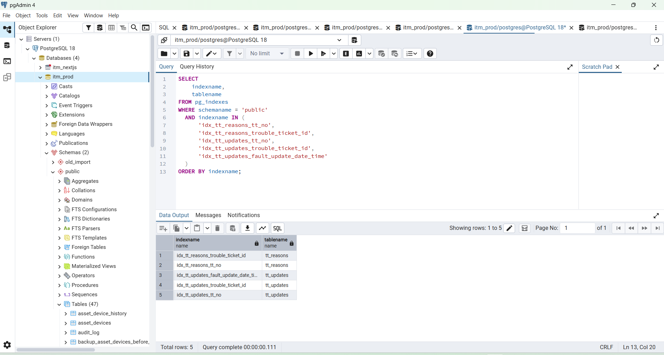

SELECT
conname AS constraint_name,
conrelid::regclass AS table_name,
confrelid::regclass AS referenced_table
FROM pg_constraint
WHERE conname IN (
'fk_tt_reasons_trouble_ticket',
'fk_tt_updates_trouble_ticket'
);

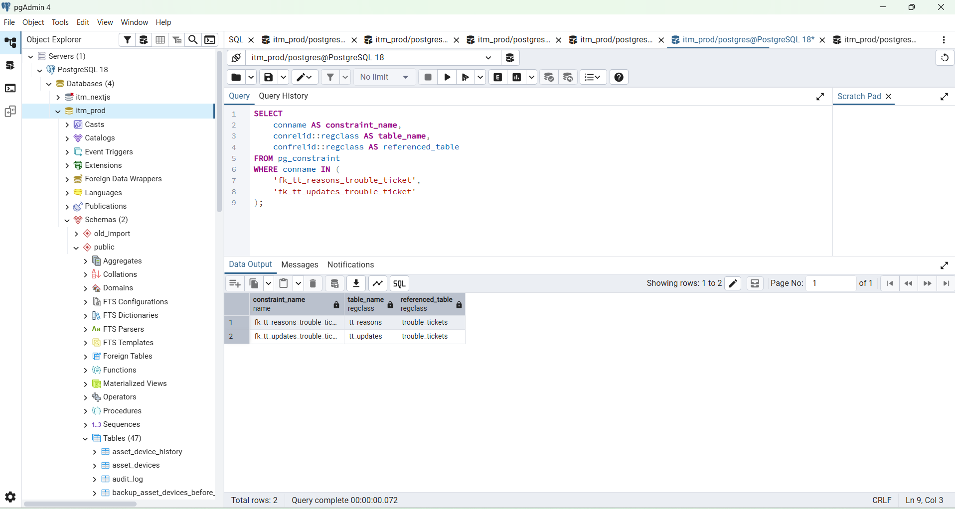

SELECT
ticket.id,
ticket.tt_no,

reason.approved_val,

CASE reason.approved_val
WHEN 1 THEN 'Petty Cash (Approved)'
WHEN 3 THEN 'PR (Approved)'
WHEN 2 THEN 'Rejected'
ELSE ''
END AS requisition_type,

reason.delivered_val,

CASE reason.delivered_val
WHEN 0 THEN 'Pending'
WHEN 1 THEN 'Delivered'
WHEN 2 THEN 'Rejected'
ELSE ''
END AS delivered_status,

latest_update.tt_note AS latest_update_note,
latest_update.fault_update_date_time AS latest_update_at

FROM public.trouble_tickets AS ticket

LEFT JOIN LATERAL (
SELECT
tt_reason.approved_val,
tt_reason.delivered_val
FROM public.tt_reasons AS tt_reason
WHERE tt_reason.trouble_ticket_id = ticket.id
ORDER BY
tt_reason.created_at DESC NULLS LAST,
tt_reason.id DESC
LIMIT 1
) AS reason ON TRUE

LEFT JOIN LATERAL (
SELECT
tt_update.tt_note,
tt_update.fault_update_date_time
FROM public.tt_updates AS tt_update
WHERE tt_update.trouble_ticket_id = ticket.id
ORDER BY
tt_update.fault_update_date_time DESC NULLS LAST,
tt_update.id DESC
LIMIT 1
) AS latest_update ON TRUE

WHERE BTRIM(ticket.tt_no::text) = '2026072129719';

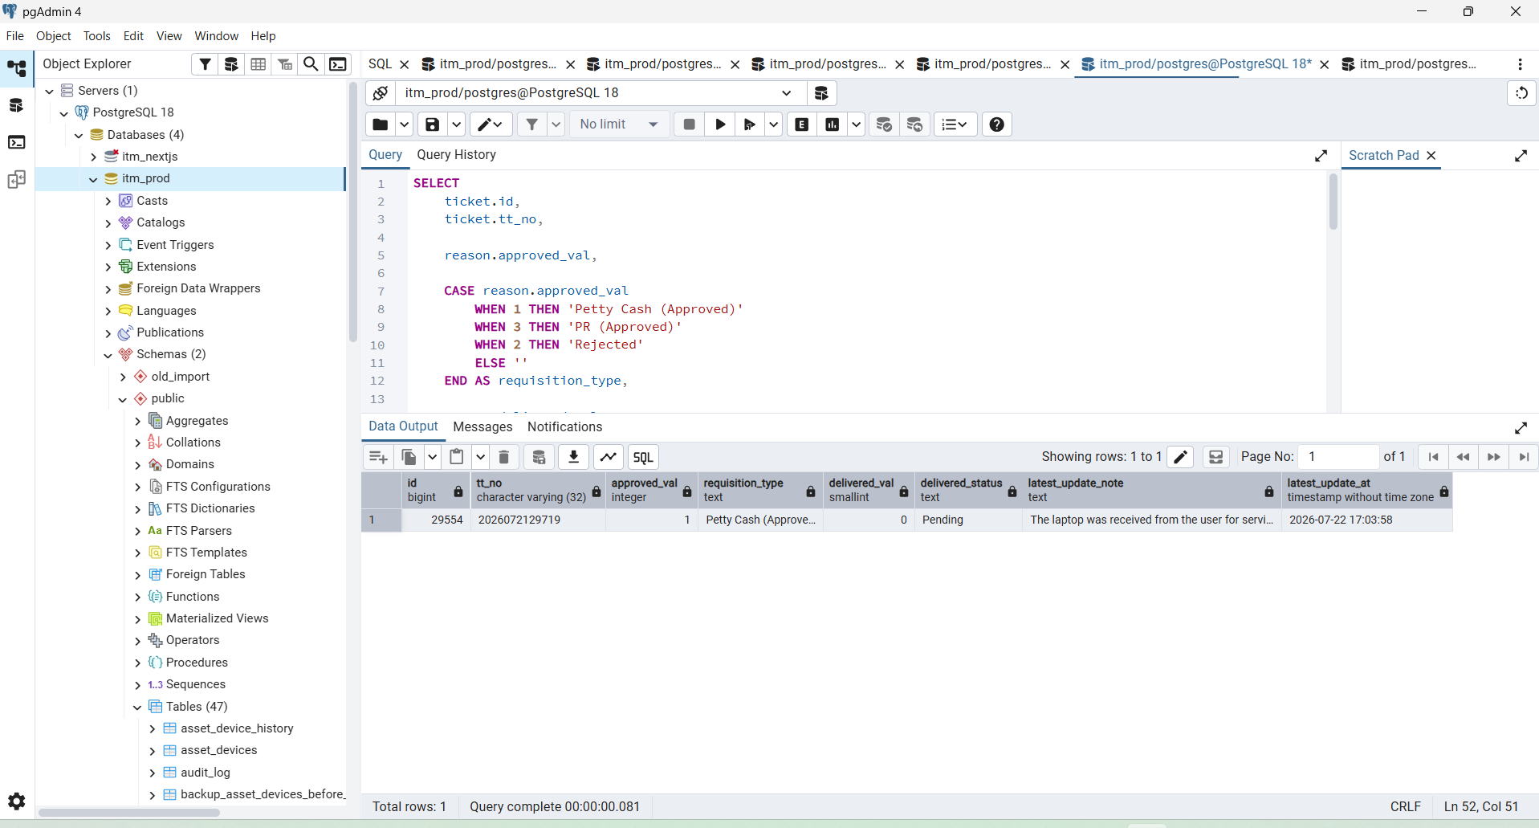

Using Postman

Method : GET
http://127.0.0.1:8080/api/v1/dashboard/trouble-tickets?search=2026072129719&page=1&limit=10

{
"data": [
{
"id": 29554,
"tt_no": "2026072129719",
"employee_id": "02-2052",
"employee_name": "Saumitro Kumer Sarder",
"assigned_id": "",
"assigned_name": "02-2248",
"query_type": "Graphics of Display problem, Laptop is quite slow and unable to execute many tasks using our portal.",
"requisition_type": "Petty Cash (Approved)",
"status": "Closed",
"dept_name": "Technology and Operations",
"func_name": "IT",
"delivered_status": "Pending",
"created_at": "2026-07-21 13:58:46+06",
"age_seconds": 178977,
"mobile_no": "01717502816"
}
],
"page": 1,
"page_size": 10,
"success": true,
"total": 1
}

https://chatgpt.com/g/g-p-6a5378cdfc588191b929a3b5ca9c1c9a/c/6a6aea6e-6794-83e8-a9d3-22852803845a

Your Postman response is correct. The backend already returns:

